Researching different areas of Graphic Design

Introduction:
In this essay, I will research lots of different types of graphics and the different designers within the multiple different fields. The main question that intend to have had answered by the end of this essay is, ‘What is my favourite genre of graphic design?’. I enjoy looking at the work of quite a few designers who are into advertising and logo design so I will definitely incorporate some of these. I also intend to research some artists who use interesting typefaces and typography in their work as this is a field that interests me. Another field that interests me is minimalist graphics. In my research, my main intention is to compile lots of different artists from the different fields as well as a bit of their background and some of my favourite examples of their work. This research means that I can find artists that I like and in turn try and use them for inspiration and influence. I think that a theme for this research will especially be looking at typographers and minimalist graphic designers as they are both fields that I am interested in.

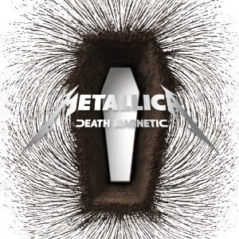
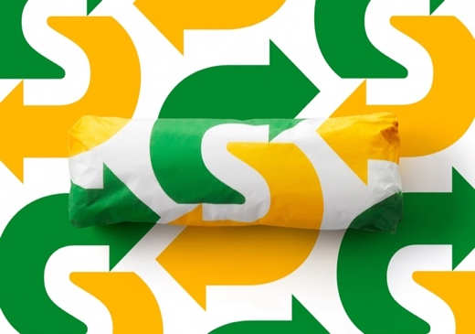
The first company I am going to look into is Turner Duckworth. The company was formed by David Turner and Bruce Duckworth in 1990. They have gone on to win many awards including the Cannes Grand Prix of Design for work with Coca Cola and even a Grammy for their work with the band, Metallica. Their main field is packaging in which they use creative colours they use and unique shapes to make their work. The techniques and ideas they have mean that their pieces are very modern. They use bold and interesting shapes to create their logos and designs. They also do their own photography that is often used in their work that is then backed up with editing and other techniques. Their work is quite trendy would attract a younger age range mainly due to the simplicity and attractiveness of their designs. In recent years, they have had huge amounts of success. Some of their more notable pieces include artwork for Metallica including their logo alongside work for Amazon (the main logo), McDonalds, Samsung and Coca-Cola. Turner Duckworth also take logos from other designers and adapt them to make them fit to products however this doesn’t stop their products being very popular and attracting a wide range of people. Sarah Moffat who is part of Turner Duckworth, has influences from John Baldessari. When looking at both people’s work you can sometimes see similarities in certain areas.
Fig.2

Fig.1

Here are two pieces that have been designed by Turner Duckworth. Fig. 1 is the album art for the bands 9th album ‘Death Magnetic’. It was designed by Turner Duckworth with influences from the band (mainly guitarist and frontman James Hetfield). The concept is very simple with the coffin representing death and then the magnetised particles behind it. However, the simplicity means it can be interpreted in different ways. ‘For instance, James [Hetfield] saw the coffin shape as more of a door than a coffin.’ This artwork would have 3 main targets. The first being obviously fans of the band. The second being general fans of music. And finally, people who generally like album covers Fig.2 depicts some packaging for ‘Subway’. The green, yellow and white all work well together. This piece is made up with the food package and a background that has been made to match the packet. They have cleverly made it so that the arrows on the item match up with the background so the package almost blends in. These particular products would attract a younger market mainly because of the product that is being advertised. This type of graphics also attracts people who like food art and packaging. What makes their designs so good is their ability to make a range of pieces at a high quality. They can make successful pieces in multiple styles which makes them very versatile.

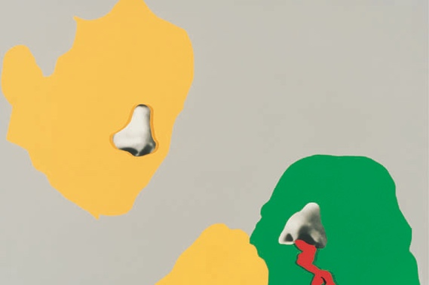
Another company whose work I am going to look into is that of The Design Republic. The company was founded in Sheffield in 1986 by Ian Anderson and Nick Phillips. Like Turner Duckworth, they have designed lots of pieces for musicians, bands and record labels due to Anderson managing a band before the creation of TDR. I particularly like the typography and fonts that they use. They use a kind of techno/retro font in some of their pieces that I could possibly recreate. Like many other designers, they also use bright and vibrant colours to make their pieces interesting. I noticed a recurring theme of dark red appearing in their pieces. Their products would probably attract an older generation. I think this because their designs are fairly simple and have relatively muted colour schemes. Another factor that could affect the target could be events/companies they are advertising and how they are probably aimed at a certain generation. They have also had so very high brow customers with work for big companies such as Adidas, Lynx, Rockstar Games, Coca-Cola and Sony. Anderson says he is influenced by all art he sees. When he looks at art, ‘he doesn’t particularly take note of the piece as a whole, he looks at the individual elements that make up the piece.’ He takes influence from these. I really like this approach as it shows he is open to anything and everything. This also explains why they have such a wide range of designs in different styles.

Fig.3 shows a piece by John Baldessari. As you can see, there is a definite similarity especially the colours that are used. A comparison with Fig.2 shows that the yellow and green used are almost identical. The shapes used are also all smooth and flowing instead of straight and rigid. This can also be seen in some of Turner Duckworth’s pieces with them also including lots of flowing lines.
Fig.3

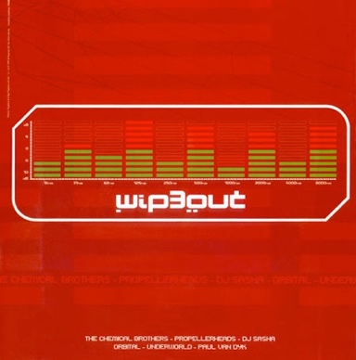
Fig.4
Fig.5

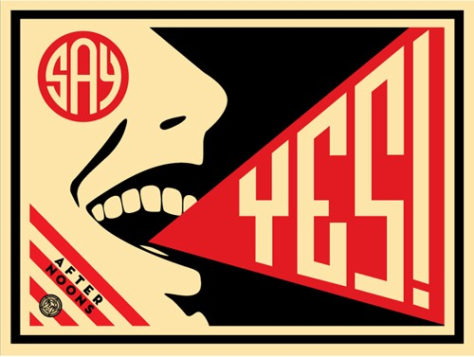
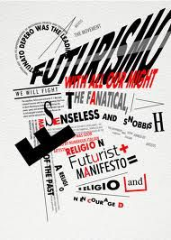
Here are two pieces by the Design Republic. Fig.4 shows a poster advertising a music festival. This is the red that they use repeatedly in their other work. The purpose of this piece is obviously trying to attract people to the festival. The contrast of the green and red is very appealing. This piece is made up of 3 main components. The red background, the artwork itself and the text below it. All of this works together well to make an attractive poster. The main thing I notice that works well in this poster is the contrast between the green in the logo and the red. This is a common combination and has been used effectively here. Fig.5 advertises a company called ‘Future Proof’. It contains their signature techno style typeface. By deconstructing the piece, you again end up with 3 main elements, the yellow background, the text and the shape. These have all been carefully selected and placed to make the piece seem whole. The main thing that works well in this is its simplicity. There are only a few elements used but the piece as a whole works very well. The main influence I could take from their work is the use of the techno-font. This contrary to the colours attracts the younger generations.
Fig.7
Fig.6
Neville Brody is the next artist I am going to look into. He is a graphic designer and typographer who was born in April 1957. Brody made his name after his work was featured in ‘The Face’ which was a British music and culture magazine. His designs were supposed to grab the attention of the reader and make them stay on that page instead of skipping through. His reputation continued to grow as he launched the FUSE project alongside Jon Wozencroft in 1991. It is a magazine that explores the stereotypes within graphics and goes against them. In lots of his pieces, uses a stencil typeface which looks effective on the block of colour that makes up the background. I have noticed that lots of his backgrounds are either red or black. I think he does this so that the plain background allows the typography work to really stand out. If the background had multiple colours and patterns, then it would have taken away from the text. He is one of the first artists responsible for studying the fusion between graphic design and typography.

Here are some influences for Neville Brody. He was heavily influenced by the Russian Constructivism movement in the 1920s (Fig.6) and the Italian Futurism movement in the 1930s (Fig. 7). Some futurists he was inspired by include Boccioni and Marinetti. It is clear to see the likeness especially in Fig.5 with the colours and fonts being similar.

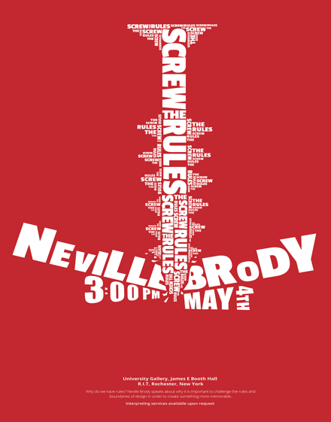
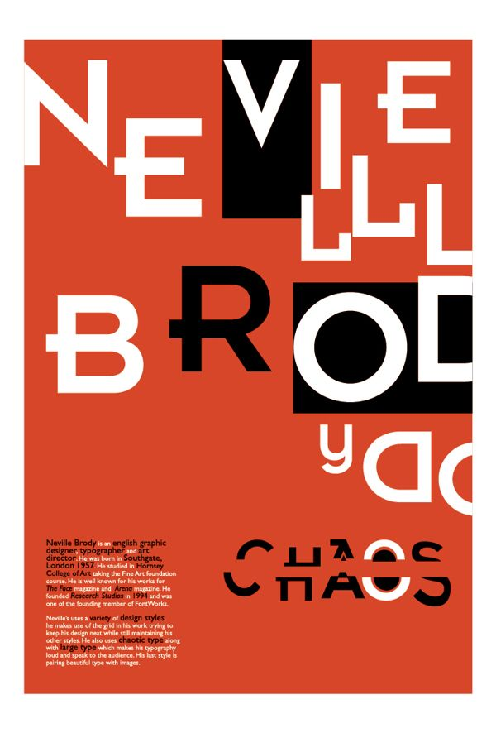
Fig.8
Fig.9

This is some work by Neville Brody that I think really shows off his creativity. Fig.8 is a large piece with his name cleverly spread out and arranged. I like the split down the word ‘CHAOS’ and how the two halves have been slightly moved making them seem uneven. Fig.9 is also very clever. He has arranged the text to form a screw which links to what he is advertising. The word ‘screw’ is also much larger which makes it stand out. He has also placed his name at the bottom to make it look like the screw is going through something. The obvious message from this piece is the advertisement for the event.

Both of these pieces also have the single-colour background that I mentioned earlier. I think that these pieces would attract all kinds of different people especially people who appreciate typography. A combination of these and other factors has given Brody a reputation of being one of the best-known current typographers. His designs are very easy on the eye, so really, anyone could appreciate them. I could definitely take influence from Neville Brody, especially from the typography and the one colour background.

The final designer I will cover in this essay is Noma Bar. His field of work is minimal graphics/illustrations. Some of his pieces are very clever and unique. When looking at his work, the first thing I notice is the vibrant colours that he uses. His work is very clever due to him being able to convey a powerful and specific message using only basic designs and few colours. His pieces all have different meanings mostly on topical issues with politics being a common topic. I think that his pieces can attract a wide range of people, for example, people who like minimalist graphics and people who like political and controversial pieces.
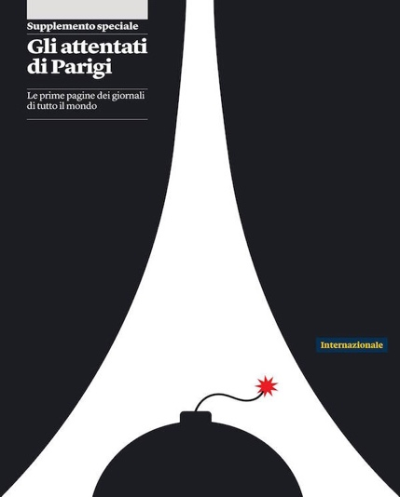
Fig.11
Fig.10

Fig. 10 shows a piece by Noma Bar of Donald Trump. As I mentioned earlier, this portrays a very clever message using only a simple outline and six colours. I believe it is a dig at Trumps use of Twitter as the logo has been flipped and used as his hair. Trump has made his use of Twitter very public which in turn has led to some controversies. I believe this is why Bar made this piece so as to graphically voice these controversies. Fig 11 is also has very political themes. It shows the Eiffel Tower with the arches at the bottom, the outline of a bomb. This is very effective as he only uses three colours which creates a very sombre mood for the piece. The fuse of the bomb stands out as it is the only colour that isn’t black or white. A message I get from this piece is one of mourning. I feel the piece is a memorial due to the simplicity and few colours.

Comparison:

It is hard to compare the artists who are in different fields to one another, but I can with those who do similar work. For example, Neville Brody and The Design Republic have some pieces that are comparable.
Fig. 11 is an example by Neville Brody and Fig. 12 is a piece by The Design Republic. On first glance, these pieces look very different but if you take some time to look closer, beyond the drastically different colour schemes, there some clear similarities. They both include a bold and punchy font that jumps out and grabs my attention. The way that both artists have elongated some of the letters also makes the text more interesting to read. They also both have text and images placed all over the work so everywhere you look you see something different. Their styles are similar as both use similar techniques and sometimes fonts.
Fig.12
Fig.11

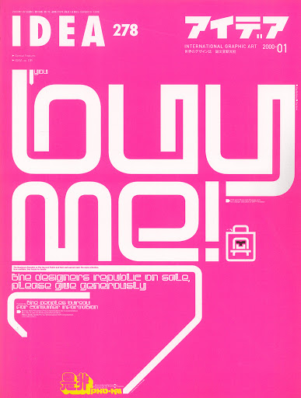
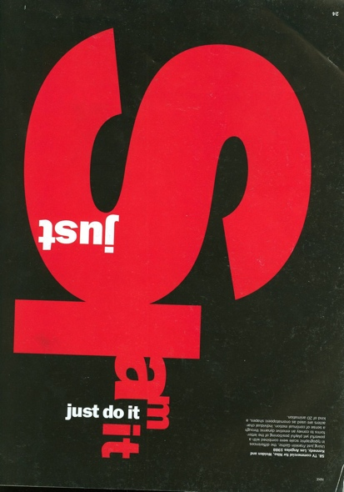

There are also some artists who have a few comparisons but are otherwise very different from one another. For example, Noma Bar and Neville Brody’s pieces share a few similarities but the majority of other factors are different.
Fig.13 is a piece by Noma Bar and it shows his clever nature by combining the flame and the Penguin. You can see that this piece is an example of one where he uses a block colour for a background. Some differences include the number of elements included. Bar uses very few components whereas Brody has lots which are much more spread out and busy (the multiple layers of text, variations in font and different angles).
Fig.14

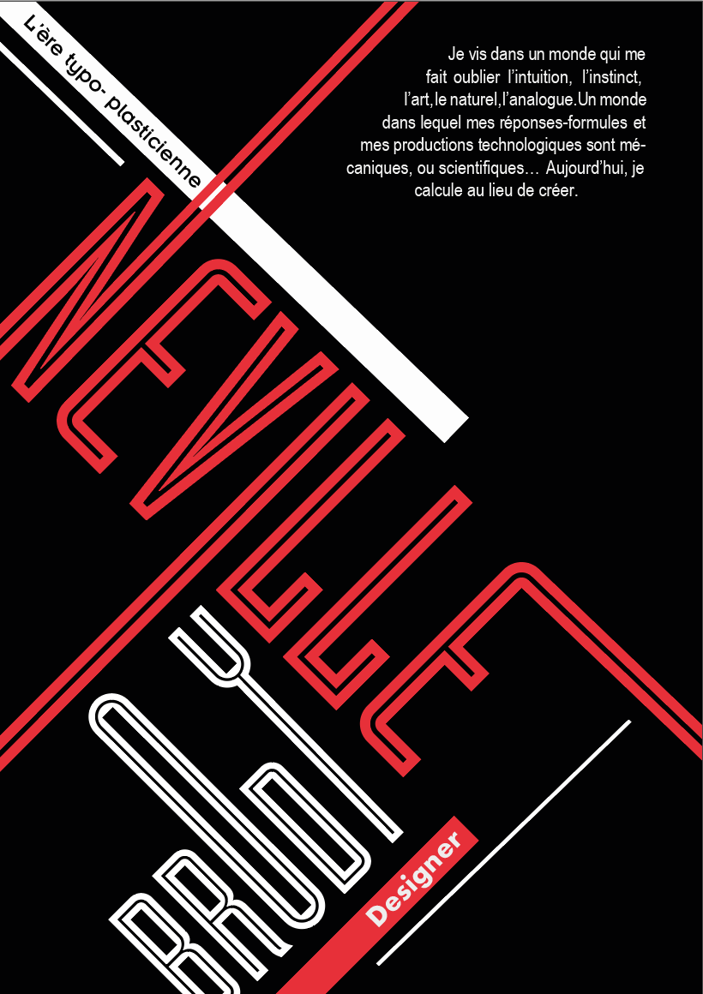

Fig.13
Fig.14 by Neville Brody shows the difference between him and Bar. Brody’s piece includes lots more elements and is much more complicated. They both portray clever messages, but each artist has a different way of showing theirs. Both artists have a different approach to their messages and designs. Bar intends to deliver a political message in a simple way whereas Neville Brody uses text, fonts and alignments to portray his messages.

Conclusion:

Overall, I enjoyed researching the artists. I learned a lot and also discovered some new designers. In my introduction, I set a theme and some questions for my research. The answer to the question from my introduction (‘What is my favourite genre of graphic design?’). Through this research, I have found that I really enjoy the minimalist field. I find it very clever that designers, such as Noma Bar, can paint such a powerful message using so few components and colours. This research has allowed me to learn more about them and their influences so I can use elements in my own designs. One flaw in my research, is that I researched too many people and most of them I didn’t need because I am not going to have their style in my piece. It was interesting to research these people, but it was not necessary for my final product. In this essay, I only selected 4 out of a total of 35. There are lots of differences between all the artists. They have quite different styles and different fields however I feel I can draw influences from all of them. Duckworth does lots of vibrant packaging and photography whilst the TDR do more retro artistic pieces. Neville Brody with the busy typography and Noma Bar with more minimalist and eye-catching pieces. Overall, the ones I picked, I enjoy the work of and feel I could use their influence in my final piece.

Bibliography:
Articles:
Nudd, T. (2020) A Guide to Spearman’s Rank2 Minutes With ... Sarah Moffat, Global Chief Creative Officer of Turner Duckworth. Available at: https://musebycl.io/creative-portraits/2-minutes-sarah-moffat-global-chief-creative-officer-turner-duckworth (Accessed: 21st October 2020).
Turner Duckworth (2020) Turner Duckworth. Available at: https://turnerduckworth.com (Accessed: 15th October 2020)

Turner Duckworth (2020) Turner Duckworth Subway. Available at: https://turnerduckworth.com/subway (Accessed: 16th October 2020)

Turner Duckworth (2020) Turner Duckworth Subway Metallica (Branding a Band). Available at: https://turnerduckworth.com/metallica (Accessed: 16th October 2020)

Beer, J. (2008) BRANDING METALLICA. Available at: https://adage.com/article/behind-the-work/branding-metallica/131085 (Accessed: 2nd November 2020).

Butler, A. (2013) Interview with ian anderson founder of the designer’s republic. Available at: https://www.designboom.com/design/ian-anderson-the-designers-republic-interview/ (Accessed: 21st November 2020).

Butler, A. (2014) Interview with graphic designer neville brody. Available at: https://www.designboom.com/design/interview-with-graphic-designer-neville-brody-10-10-2014/ (Accessed: 2nd November 2020).

Bilbeisi, Y. (2013) Glass interviews artist John Baldessari one of the most respected contemporary artists of the last five decades. Available at: https://www.theglassmagazine.com/pure-beauty/ (Accessed: 23rd October 2020).

Ribi, N. (2019) Noma Bar tells Haaretz how minimalism and optical illusions have helped him portray leaders including Stalin, Assad and Osama bin Laden. Available at: https://www.haaretz.com/israel-news/.premium.MAGAZINE-israeli-art-trump-assad-stalin-minimalism-1.8008077 (Accessed: 3rd November 2020)

Images I used:
https://www.pinterest.ca/pin/319966748522403708/
https://www.designweek.co.uk/issues/june-2008-online/design-groups-shine-at-cannes/
https://mymodernmet.com/noma-bar-new-secret-storytelling-illustrations/
http://www.designishistory.com/1980/the-designers-republic/
https://www.pinterest.co.uk/pin/134615476331932469/
https://www.pinterest.co.uk/pin/177047829075699457/
https://www.pinterest.co.uk/pin/410531322254005618/

